Model will memorize the chat history by adding the placeholder in the prompt, that will contains a list which will store all the chats

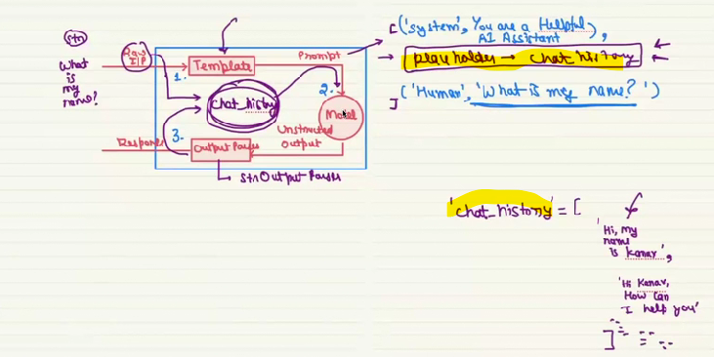

**STEPS TO IMPLEMENT IT**

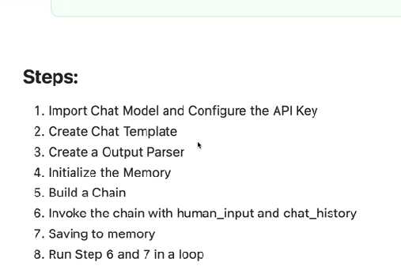

Lang graph is the module which helps to create the storage area.



